Experiment 8
Name : Varad Satish Nashikkar
Roll No : 42454

Index.html :
<!DOCTYPE html>
<html lang="en">
<head>
<meta charset="UTF-8">
<title>Home Page - BG Color Change</title>
<link rel="stylesheet" href="styles.css">
</head>
<body>
<h1>🎨 Home Page by Varad</h1>
<p>Background color changes on hover and focus event</p>

<button id="hoverBtn">Hover Over Me</button><br><br>

<input type="text" id="focusInput" placeholder="Click here to focus">

<script src="script.js"></script>
</body>
</html>

Styles.css :
body {
font-family: Arial, sans-serif;
text-align: center;
transition: background 0.5s;
background: #f4f4f9;
padding: 50px;
}

h1 {
color: #333;
margin-bottom: 30px;
}

button {
padding: 15px 30px;
font-size: 1rem;
cursor: pointer;
border: none;
border-radius: 8px;
background: #0077b6;
color: white;
transition: background 0.3s;
}

button:hover {
background: #023e8a;
}

input {
padding: 10px;
font-size: 1rem;
border: 2px solid #ccc;
border-radius: 5px;
margin-top: 20px;
outline: none;
}

input:focus {
border-color: #0077b6;
box-shadow: 0 0 5px #0077b6;
}

Script.js :
const body = document.body;
const hoverBtn = document.getElementById("hoverBtn");
const focusInput = document.getElementById("focusInput");

hoverBtn.addEventListener("mouseover", () => {
body.style.background = "#caf0f8";
});
hoverBtn.addEventListener("mouseout", () => {
body.style.background = "#f4f4f9";
});

focusInput.addEventListener("focus", () => {
body.style.background = "#ffe5ec";
});
focusInput.addEventListener("blur", () => {
body.style.background = "#f4f4f9";
});

- Click On Button :

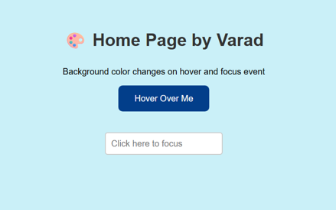

- Click on Input Box

